Agile Planning and Portfolio Management with Visual Studio Team Services

Lab version: 15.7.3

Last updated: 6/19/2018

1. **TABLE OF CONTENTS**

Overview 1

Prerequisites 1

Exercise 1: Agile Project Management 1

Task 1: Working with teams, areas, and iterations 1

Task 2: Working with work items 7

Task 3: Managing sprints and capacity 17

Task 4: Customizing Kanban boards 27

Task 5: Defining dashboards 35

Task 6: Customizing team process 43

# Overview

* 1. In this lab, you will learn about the agile planning and portfolio management tools and processes provided by Visual Studio Team Services (VSTS) and how they can help you quickly plan, manage, and track work across your entire team. You will explore the product backlog, sprint backlog, and task boards which can be used to track the flow of work during the course of an iteration. We will also take a look at how the tools have been enhanced in this release to scale for larger teams and organizations.

## Prerequisites

* This lab requires you to complete task 1 from the prerequisite instructions.

# Exercise 1: Agile Project Management

## Task 1: Working with teams, areas, and iterations

1. Navigate to your Parts Unlimited project on VSTS. It will be something like <https://YOURACCOUNT.visualstudio.com/Parts%20Unlimited>.
2. Open the settings page using the **Project settings** navigation.



1. Select the **Teams** tab. There are already a few teams in this project, but you’ll make a new one for this lab. Click **New team**.

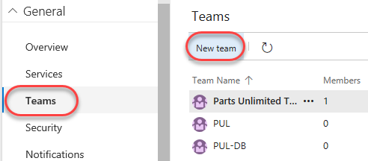

1. Use **“PUL-Web”** as the **Team name** and click **Create team**.

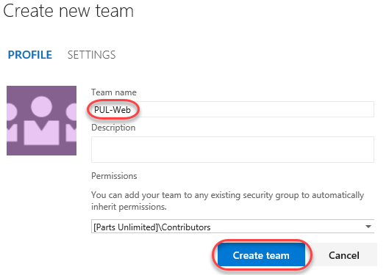

1. Select the newly created team to view its details.

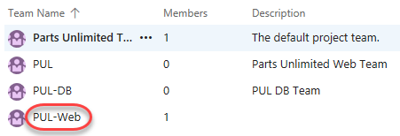

1. By default, the new team has only you as its member. You can use this view to manage membership, notifications, dashboards, and more. But first you will want to define the schedule and scope of the team. Click **Iterations and areas**.

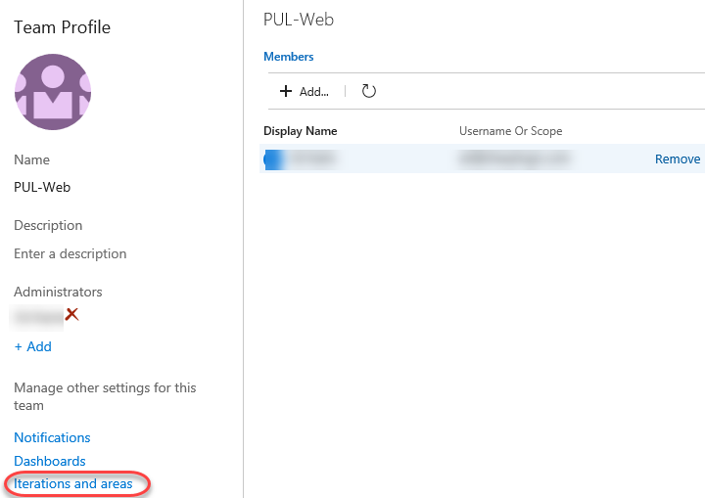

1. Select the **Iterations** tab and click **Select iterations**. This team will use the same iteration schedule that’s already in place for the other teams, although you can take a different route if that’s better for your organization.

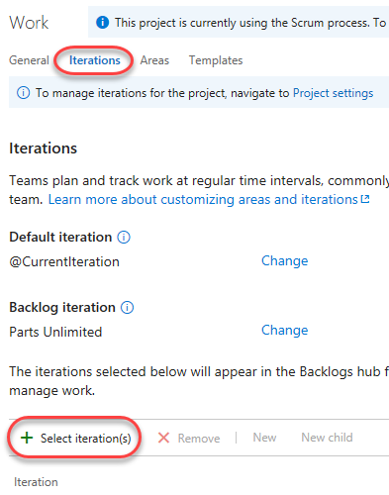

1. Select **Parts Unlimited\Sprint 1** and click **Save and close**. Note that this first sprint has already passed. This is because the demo data generator is designed to build out project history so that this sprint occurs in the past.

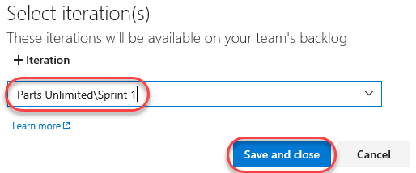

1. Repeat the process to add **Sprint 2** and **Sprint 3**. The second sprint is our current iteration, and the third is in the near future.

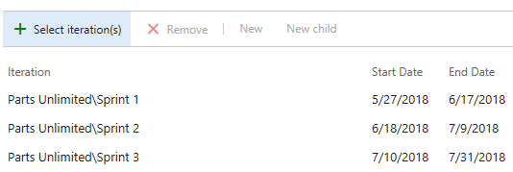

1. Select the **Areas** tab. By default, no areas are configured for a new team. Click **Project settings** to open the area configuration page in a new tab.

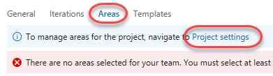

1. Make sure the root **Parts Unlimited** area is selected and click **New child**.

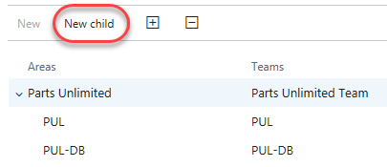

1. Name the new child **“PUL-Web”** and click **Save and close**. This area will be specifically intended for use by the team of the same name. Close the browser tab and return to the previous tab.

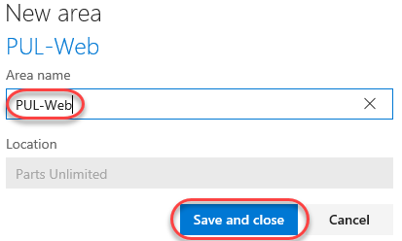

1. Click **Select area(s)**.

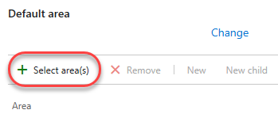

1. Select **Parts Unlimited\PUL-Web** and click **Save and close**. Note that you may need to refresh the browser for the new area to show.

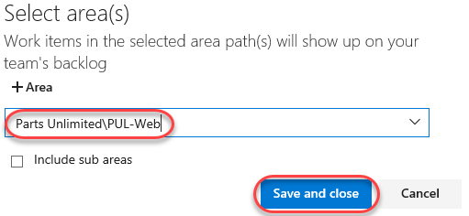

1. From the area dropdown, select **Include sub areas**. The default setting for all teams is to exclude sub-area paths. We will change it to include sub-areas so that the team gets visibility into all of the work items from all teams. Optionally, the management team could also choose to not include sub-areas. Thereby removing work items from their view as soon as they are assigned to one of the teams.

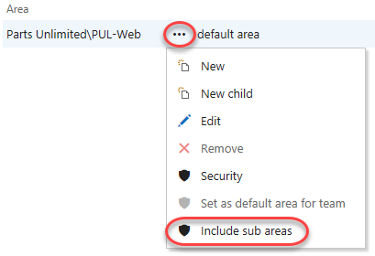

## Task 2: Working with work items

Work items play a prominent role in VSTS. Whether describing work to be done, impediments to release, test definitions, or other key items, work items are the workhorse of modern projects. In this task you’ll focus on using various work items to set up the plan to extend the Parts Unlimited site with a product training section. While it can be daunting to build out such a substantial part of a company’s offering, VSTS and the Scrum process make it very manageable.

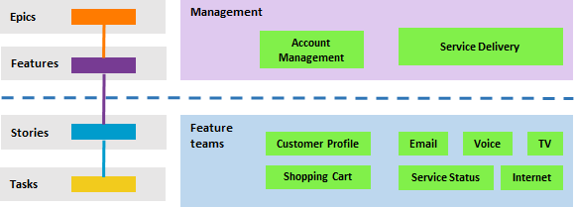

This task is designed to illustrate a variety of ways you can create different kinds of work items, as well as to demonstrate the breadth of features available on the platform. As a result, these steps should not be viewed as prescriptive guidance for project management. The features are intended to be flexible enough to fit your process needs, so explore and experiment as you go.

1. Select **Overview | Dashboards**.

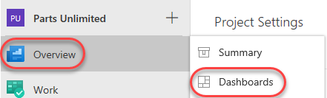

1. Select the **Overview** dashboard for **PUL-Web**.

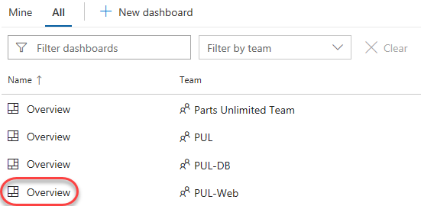

1. There are many ways to create work items in VSTS, and we’ll explore a few of them. Sometimes it’s as simple as firing one off from a dashboard. In the **New Work Item** form, type **“Product training”** and select the **Epic** type. Click **Create**.

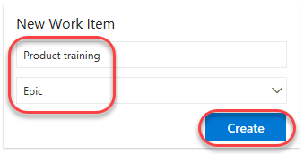

1. Assign the new work item to yourself and set the **Area** to **Parts Unlimited\PUL-Web**. Set the **Iteration** to **Parts Unlimited\Sprint 2** and click **Save & Close**. Ordinarily you would want to fill out as much information as possible, but you can run lean here for the purposes of this lab.

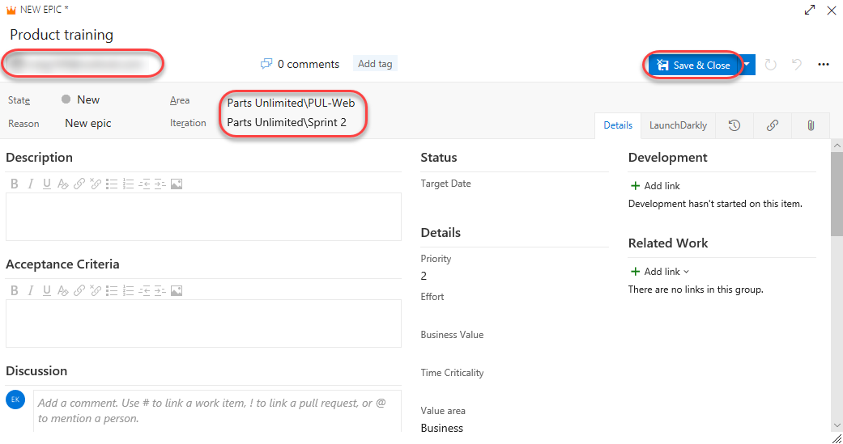

1. Select **Work | Works Items**.

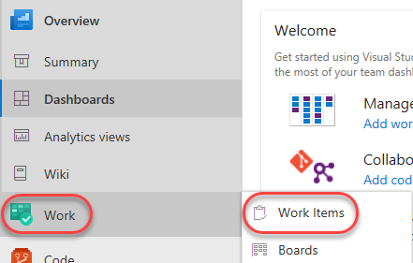

1. Locate the newly created epic for **Product training** and open it.

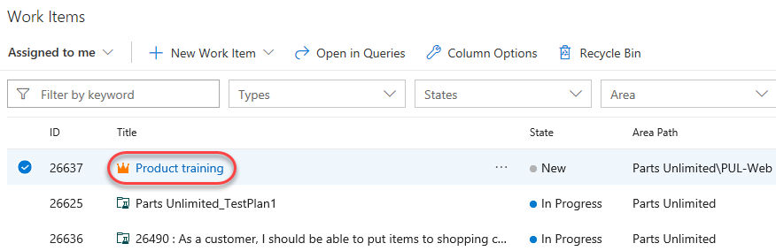

1. The work item form includes everything you could ever want to know about a work item. This includes details about who it’s assigned to, its status across many parameters, and all the associated information and history for how it has been handled since creation. One of the key areas to focus on is the **Related Work**. One of the ways to add a feature to this epic is to select **Add link | New item**.

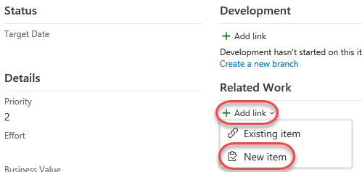

1. Set the **Work item type** to **Feature** and set the **Title** to **“Training dashboard”**. Click **OK**.

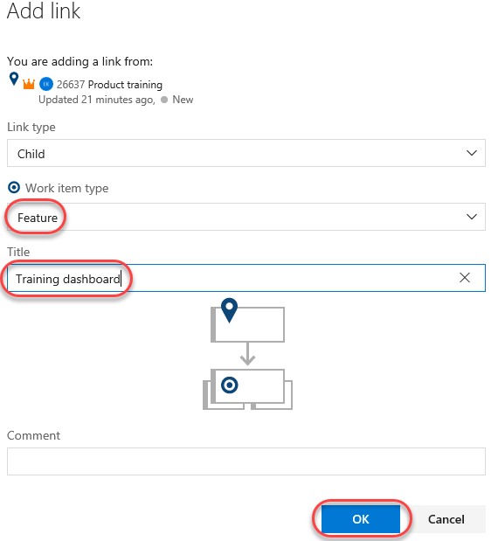

1. Assign this work item to yourself. Note that the **Area** and **Iteration** are already set to the same as the epic, and it’s even linked based on the way it was created. Select **Save & Close**.

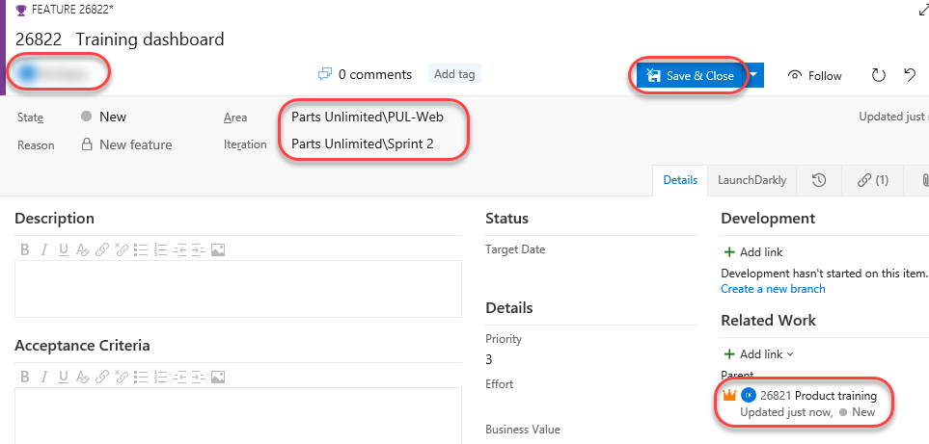

1. Navigate to the **Boards** view.

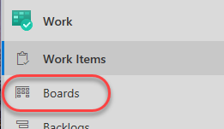

1. Select **PUL-Web Boards**. This will open the board for that particular team.

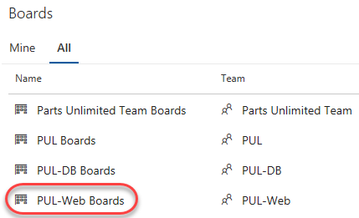

1. Switch the board from showing **Backlog items** to showing **Features**. This will make it easy to add tasks and other work items to the features.

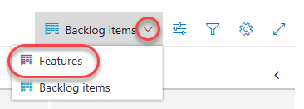

1. From the **Training dashboard** dropdown, select **Add Product Backlog Item**.

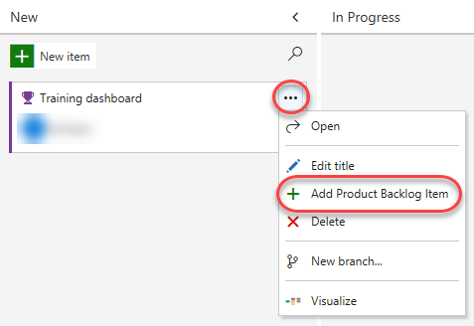

1. Name the first backlog item **“As a customer, I want to view new tutorials”** and press **Enter** to save. This creates a new **Product Backlog Item** (PBI) work item that is a child of the feature and shares its area and iteration.

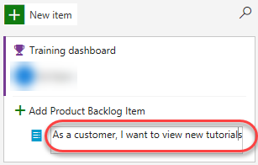

1. Add two more PBIs designed to enable the customer to see their recently viewed tutorials and to request new tutorials.

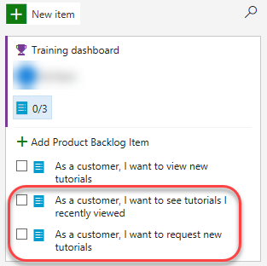

1. Switch the task board view back to **Backlog items**.

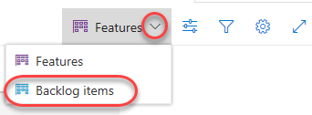

1. Backlog items have a state that defines where they are relative to being completed. While you could open and edit the work item using the form, it’s easier to just drag cards on the board. Drag the first work item to **Approved**.

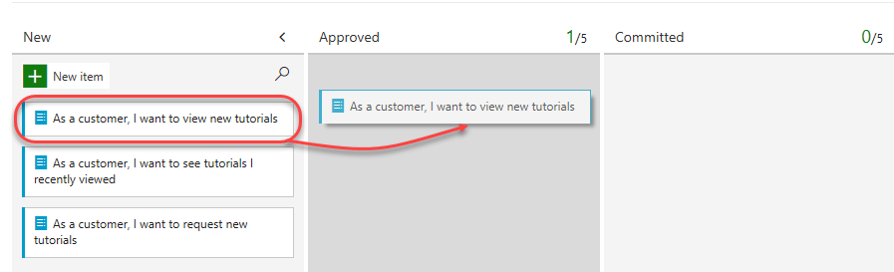

1. You can also expand work item cards to get to conveniently editable details.

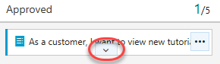

1. Assign the moved PBI to yourself.

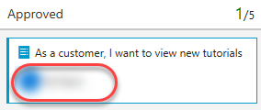

1. Note that the **Cumulative flow diagram** has updated to reflect the change in work for the team.

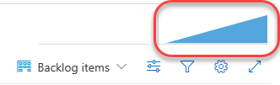

1. Drag the second work item to the **Committed** stage.

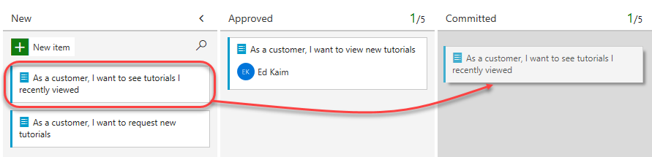

1. The CFD will update again to reflect this change in status.

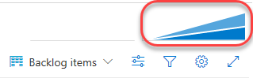

1. Drag the final PBI to the **Done** stage.

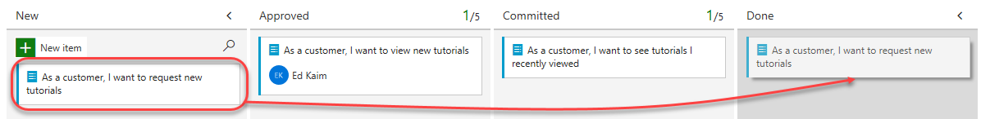

1. Click the CFD to open it.

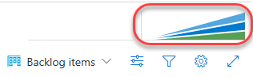

1. There are now three work items in different stages for this team.

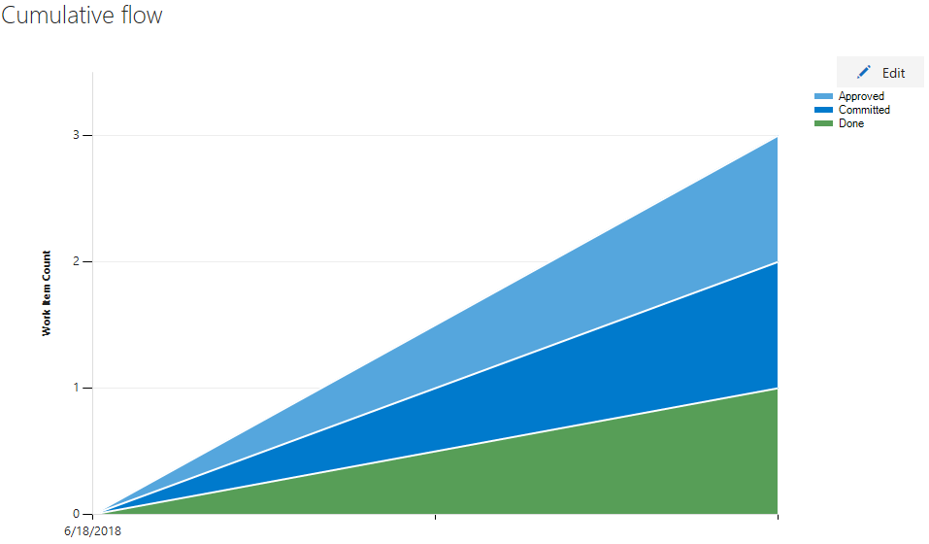

1. The task board is one view into the backlog. View the tabular form by clicking **Backlog items backlog**.

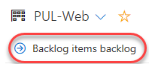

1. Click the **Expand** button, which allows you to view nested tasks under these work items. Another easy way to create work items is using the **Add** button on the backlog. Click it to add a new task to the first backlog item.

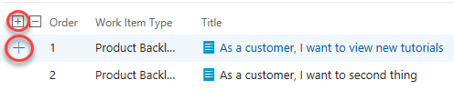

1. Set the **Title** to **“Add page for most recent tutorials”**. Set the **Remaining Work** to **“5”**and the **Activity** to **“Development”**. Click **Save & Close**.

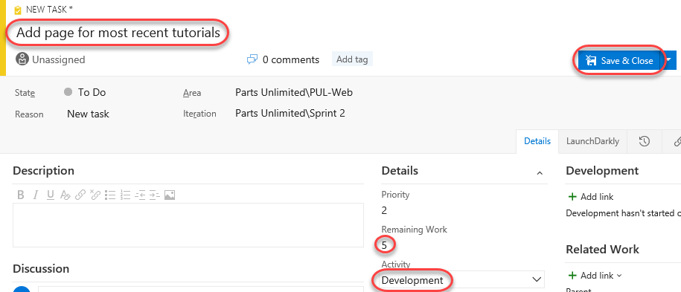

1. Add another task to **“Optimize data query for most recent tutorials”**. Set its **Remaining Work** to **“3”** and its **Activity** to **“Design”**. Click **Save & Close**.

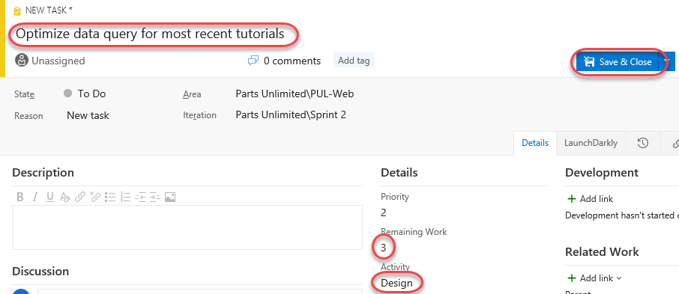

## Task 3: Managing sprints and capacity

Your team builds the sprint backlog during the sprint planning meeting, typically held on the first day of the sprint. Each sprint corresponds to a time-boxed interval which supports your team’s ability to work using Agile processes and tools. During the planning meeting, your product owner works with your team to identify those stories or backlog items to complete in the sprint.

Planning meetings typically consist of two parts. In the first part, the team and product owner identify the backlog items that the team feels it can commit to completing in the sprint, based on experience with previous sprints. These items get added to the sprint backlog. In the second part, your team determines how it will develop and test each item. They then define and estimate the tasks required to complete each item. Finally, your team commits to implementing some or all the items based on these estimates.

1. Your sprint backlog should contain all the information your team needs to successfully plan and complete work within the time allotted without having to rush at the end. Before you start planning your sprint, you’ll want to have created, prioritized, and estimated your backlog and defined your sprints. Navigate to the **Sprints** view using the navigation.

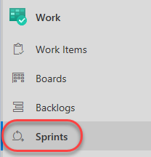

1. Select the **PUL-Web Sprints**.

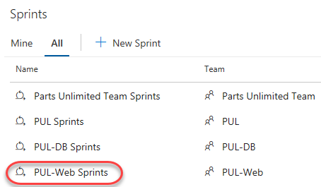

1. From the **View options** dropdown, set the **Work details** to **On**.

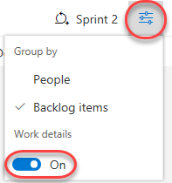

1. The current sprint has a pretty limited scope. There are two tasks in the **To do** stage that combine for 8 hours of estimated work. At this point, neither task has been assigned.

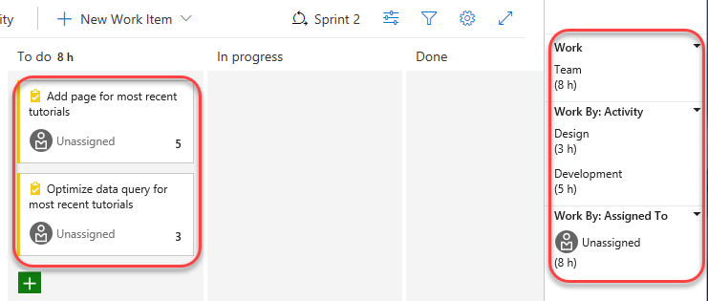

1. Assign the **Add page** task to yourself. Note that this updates the capacity view.

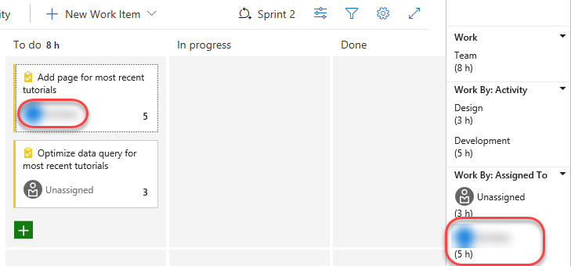

1. Select the **Capacity** tab. This view enables you to define what activities a user can take on and at what level of capacity. In this case, set your capacity to allow **“1”** hour of **Development** per day. Note that you can add additional activities per user in the case they do more than just development.

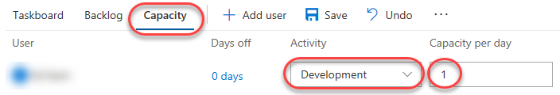

1. However, let’s assume you’re going to take some vacation. Click **0 days** under **Days off**.

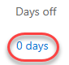

1. Set your vacation to span five work days during the current sprint (within the next few weeks). Click **OK**.

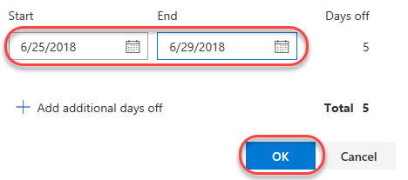

1. Click **Save**.

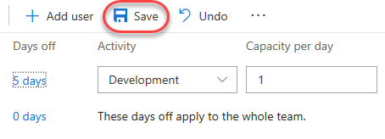

1. Return to the **Taskboard**.



1. Note that the capacity view has been updated to reflect your available bandwidth. This exact number may vary, but for the screenshots here, that sprint capacity is 11 hours (1 hour per day over 11 working days).

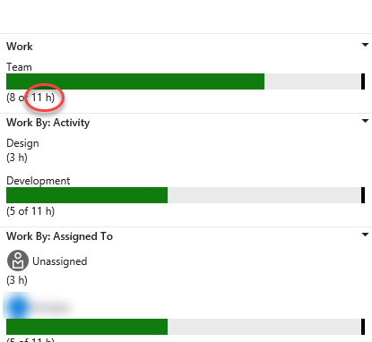

1. One convenient feature of the boards is that you can easily update key data in line. It’s a good practice to regularly update the **Remaining Work** estimate to reflect the amount of time expected for each task. Let’s say you’ve reviewed the work for the **Add page** task and found that it will actually take longer than originally expected. Set it to whatever your total capacity is for this sprint.

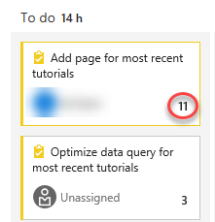

1. Note how this expands the **Development** and your personal capacities to their maximum. Since they’re large enough to cover the assigned tasks, they stay green. However, the overall **Team** capacity is exceeded due to the additional 3 hours required by the other task.

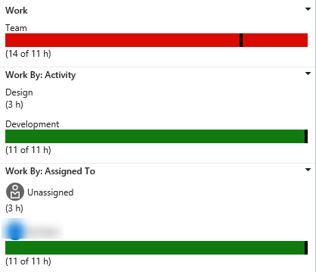

1. One way to resolve this capacity issue would be to move the task to a future iteration. There are a few ways this could be done. First, you could open the task here and edit it in the dialog. The **Backlog** view, on the other hand, provides an in line menu option to move it. Don’t move it now.

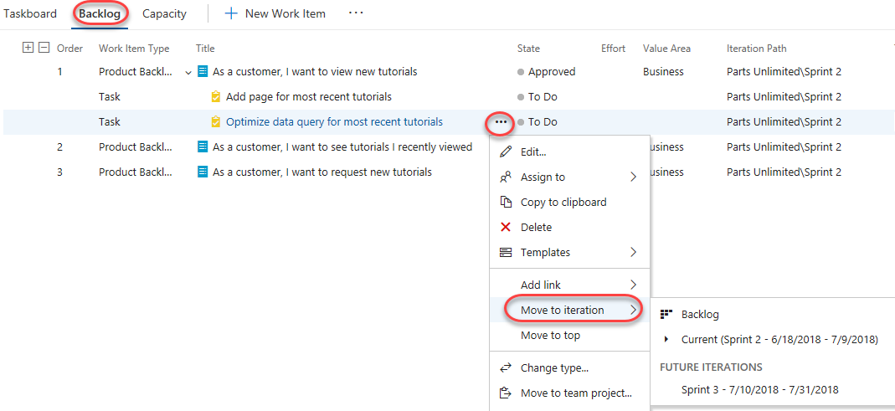

1. On the **Taskboard** view, select **People** from the **View options** dropdown.

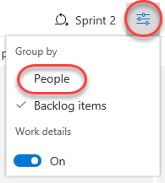

1. This adjusts your view such that you can review the progress of tasks by person instead of by backlog item.

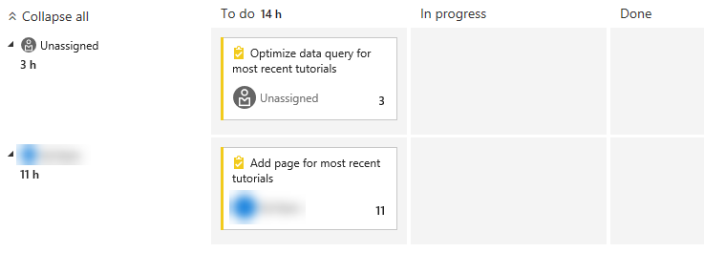

1. There is also a lot of customization available. Click the **Configure team settings** button.



1. On the **Styles** tab, click **Add Styling rule** and set the **Name** to **“Development”**. Choose a green **Card color**. This will color all cards green if they meet the rule criteria set below.

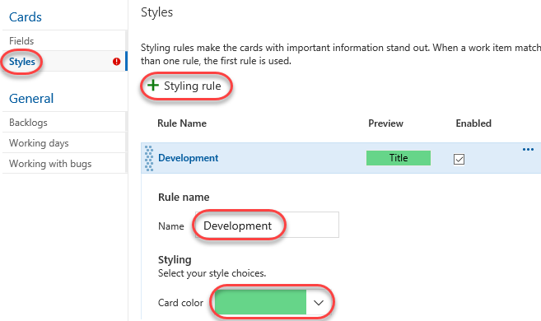

1. Add a rule for **Activity = Development**. This will set all cards assigned to **Development** activities green.

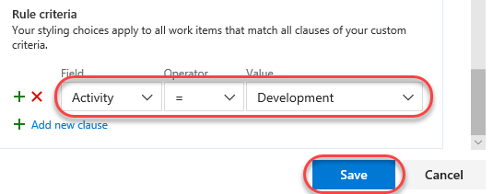

1. The **Backlogs** tab allows you to set the levels available for navigation. Epics are not included by default, but you could change that here.

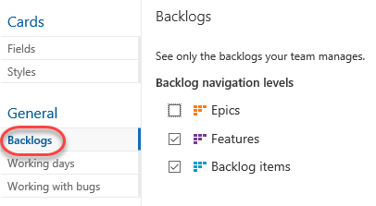

1. You can also specify the **Working days** the team follows. This applies to capacity and burndown calculations.

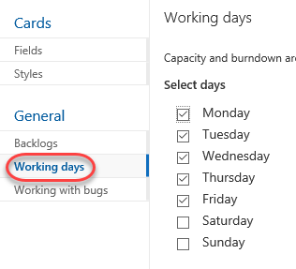

1. The **Working with bugs** tab allows you to specify how bugs are presented on the board.

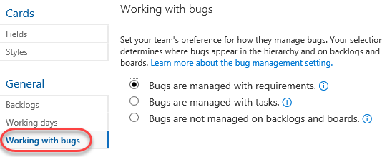

1. Click **Save** to save the styling rule.



1. The task associated with **Development** is now green and very easy to identify.

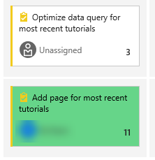

## Task 4: Customizing Kanban boards

To maximize a team’s ability to consistently deliver high quality software, Kanban emphasize two main practices. The first, visualize the flow of work, requires you to map your team’s workflow stages and configure your Kanban board to match. The second, constrain the amount of work in progress, requires you to set work-in-progress (WIP) limits. You’re then ready to track progress on your Kanban board and monitor key metrics to reduce lead or cycle time. Your Kanban board turns your backlog into an interactive signboard, providing a visual flow of work. As work progresses from idea to completion, you update the items on the board. Each column represents a work stage, and each card represents a user story (blue cards) or a bug (red cards) at that stage of work. However, every team develops its own process over time, so the ability to customize the Kanban board to match the way your team works is crucial.

1. Navigate to **Boards**.

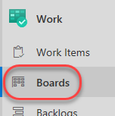

1. Click the **Configure team settings** button.



1. The team is emphasizing work done with data, so there is special attention paid to any task associated with accessing or storing data. Select the **Tag colors** tab. Click **Add tag color** enter a tag of **“data”**. Whenever a backlog item or bug is tagged with **data**, that tag will be highlighted.

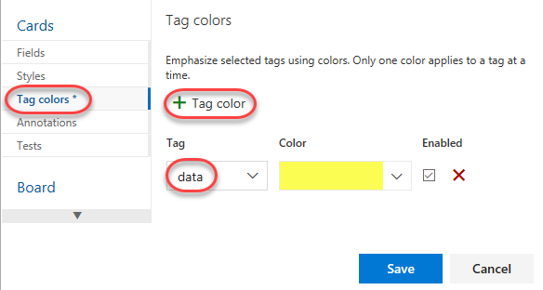

1. You can also specify which **Annotations** you would like included on cards to make them easier to read and navigate. When an annotation is enabled, the child work items of that type are easily accessible by clicking the visualization on each card.

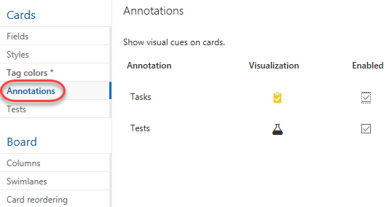

1. The **Tests** tab enables you to configure how tests appear and behave on the cards.

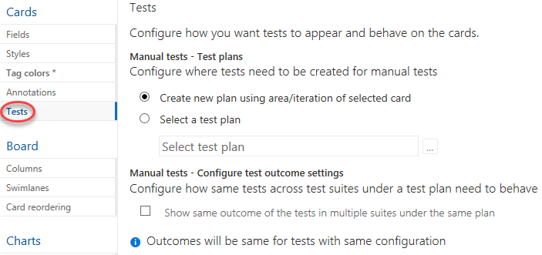

1. Click **Save**.



1. Open the **new tutorials** backlog item.

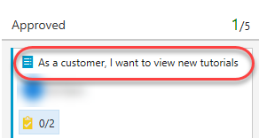

1. Add tags for **“data”** and **“ux”**. Click **Save & Close**.

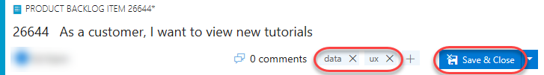

1. Note that the two tags are now visible on the card, although the **data** tag is highlighted yellow as configured.

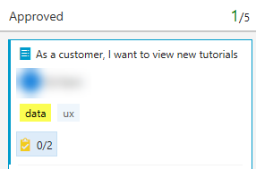

1. Click the **Configure team settings** button.



1. Select the **Columns** tab. This section allows you to add new stages to the workflow. Click **Add Column** and set the **Name** to **“QA Approved”**. Set the **WIP limit** to **“1”**, which indicates that only one work item should be in this stage at a time. You would ordinarily set this higher, but there are only two work items to demonstrate the feature with here. Move the stage to occur between **Committed** and **Done**.

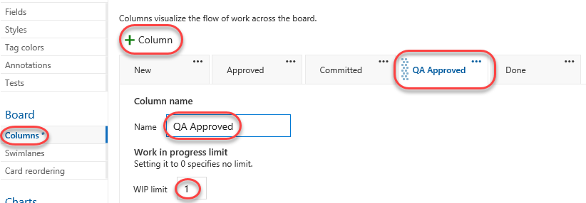

1. Click **Save**.



1. You will now see the new stage in the workflow.

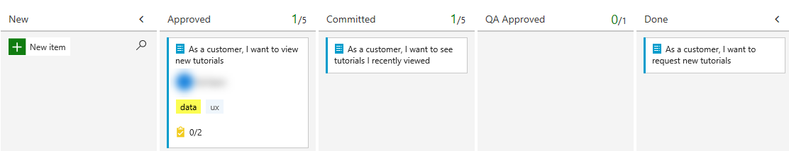

1. Move the work items from **Committed** and **Done** into **QA Approved**.

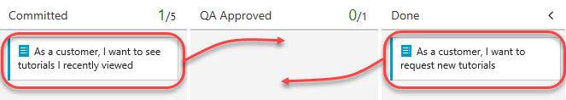

1. The stage now exceeds its **WIP** limit and is colored red as a warning.

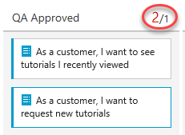

1. Move the **recently viewed** backlog item back to **Committed**.

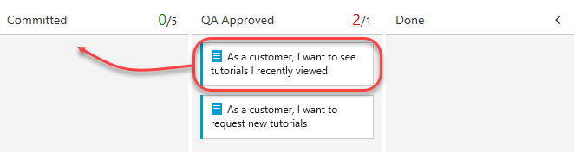

1. Click the **Configure team settings** button.



1. Return to the **Columns** tab and select **QA Approved**. A lag often exists between when work gets moved into a column and when work starts. To counter that lag and reveal the actual state of work in progress, you can turn on split columns. When split, each column contains two sub-columns: **Doing** and **Done**. Split columns let your team to implement a pull model. Without split columns, teams push work forward, to signal that they’ve completed their stage of work. However, pushing it to the next stage doesn’t necessarily mean that a team member immediately starts work on that item. Check **Split column into doing and done** to create two separate columns for this.

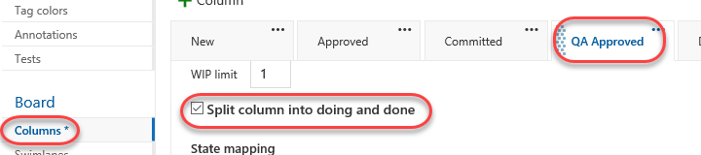

1. As your team updates the status of work as it progresses from one stage to the next, it helps that they agree on what “done” means. By specifying the **Definition of done** criteria for each Kanban column, you help share the essential tasks to complete before moving an item into a downstream stage. Add a **Definition of done** using markdown, such as **“Passes **all** tests.”**. Click **Save**.

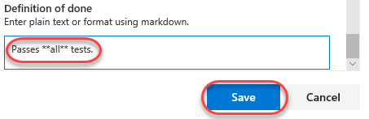

1. Note that the **QA Approved** stage now has **Doing** and **Done** columns.

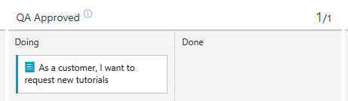

1. You can also click the icon next to the column header to read the **Definition of done**.

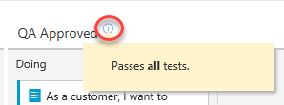

1. Click the **Configure team settings** button.



1. Your Kanban board supports your ability to visualize the flow of work as it moves from new to done. When you add **swimlanes**, you can also visualize the status of work that supports different service-level classes. You can create a swimlane to represent any other dimension that supports your tracking needs. From the **Swimlans** tab, click **Add Swimlane** and set the **Name** to **“Expedite”**. Click **Save**.

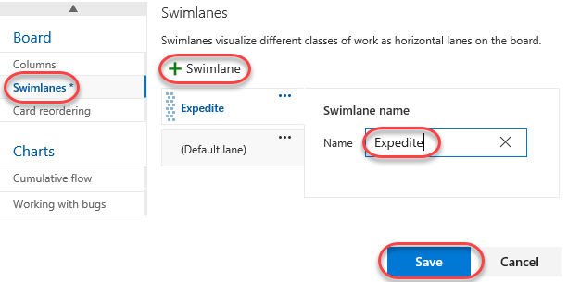

1. Drag and drop the **Committed** work item onto **QA Approved | Doing** so that it gets recognized as having priority when QA bandwidth becomes available.

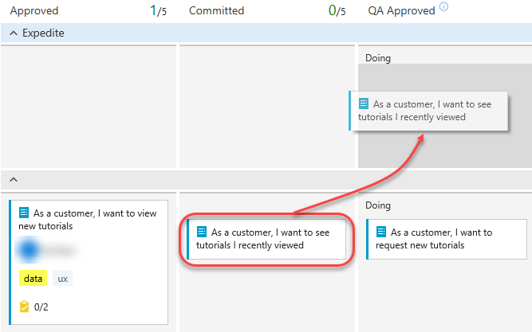

1. If you would like to review a more sophisticated board with many more work items, select the **Parts Unlimited Team** from the team dropdown.

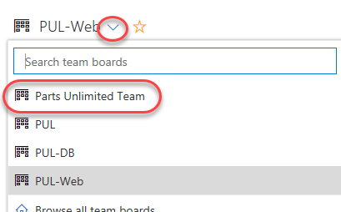

1. This board provides a playground for you to experiment with changes and review the results.

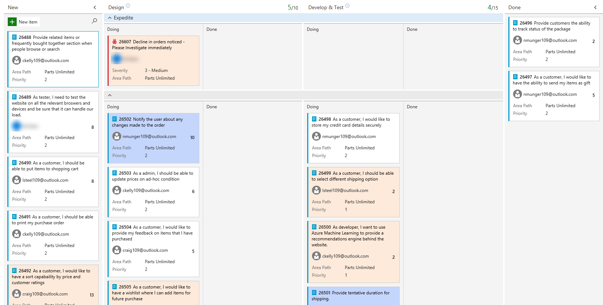

## Task 5: Defining dashboards

1. Select **Overview | Dashboards**.

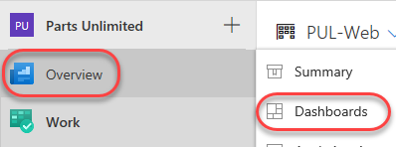

1. Dashboards allow teams to visualize status and monitor progress across the project. At a glance, you can make informed decisions without having to drill down into other parts of your team project site. The Overview page provides access to a default team dashboard which you can customize by adding, removing, or rearranging the tiles. Each tile corresponds to a widget that provides access to one or more features or functions.

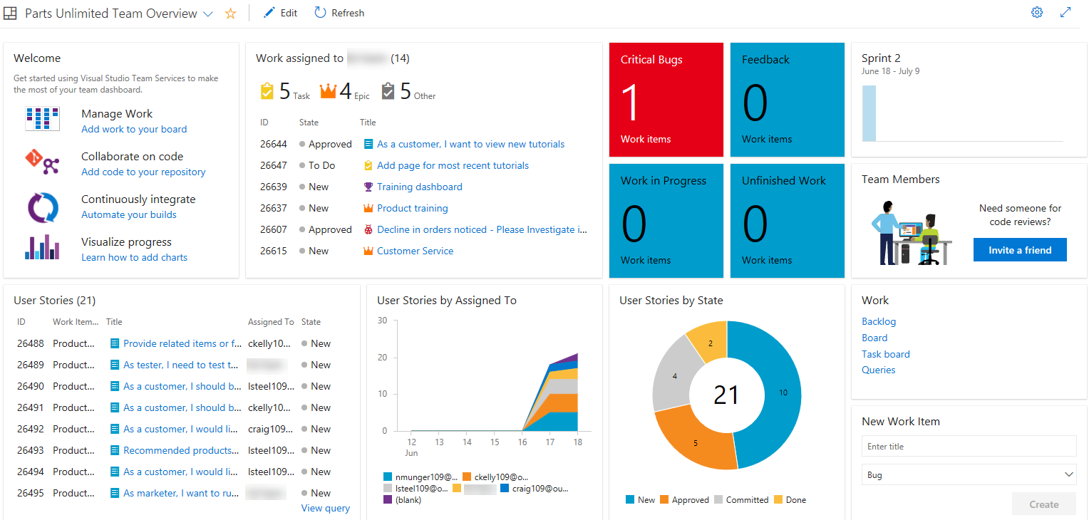

1. From the dashboard dropdown, select **New dashboard**.

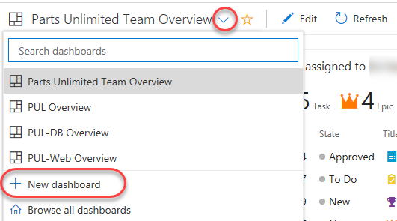

1. Set the **Name** to **“Product training”** and select the **PUL-Web** team. Click **Create**.

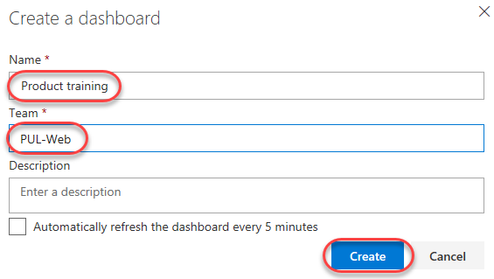

1. In the **Add Widget** panel, search for **“sprint”** to find existing widgets that focus on sprints. Select **Sprint Overview** and click **Add**.

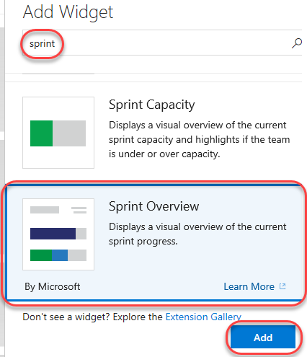

1. Many widgets have options you can configure. Click the **Settings** button.

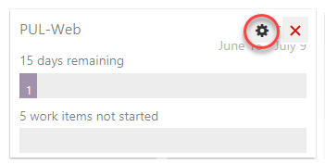

1. The quantity and depth of settings will vary by widget. Click **Close** to dismiss.

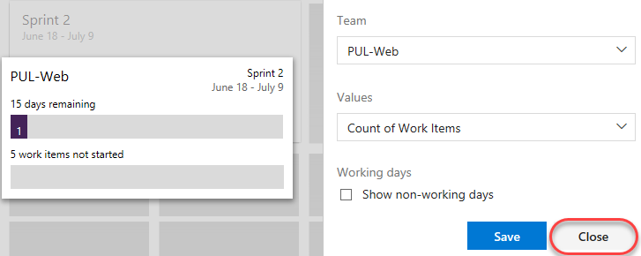

1. Search the widgets again for **“sprint”** and add the **Sprint Capacity** widget.

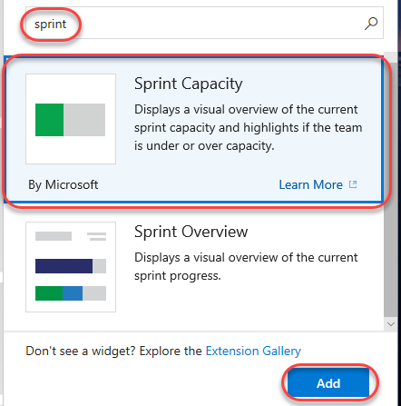

1. Click **Done Editing**.

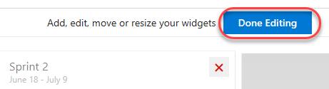

1. You can now review two important aspects of your current sprint on your custom dashboard.

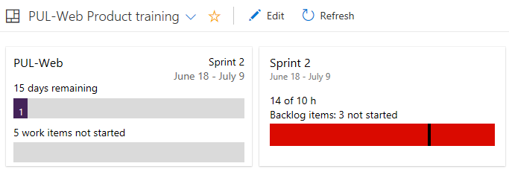

1. Another way of customizing dashboards is to generate charts based on work item queries, which you can share to a dashboard. Select **Work | Queries**.

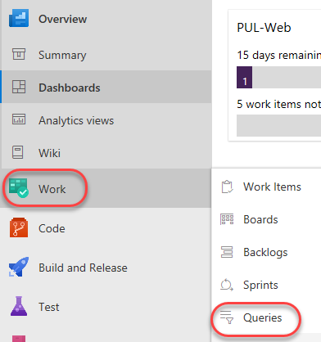

1. Click **New query**.

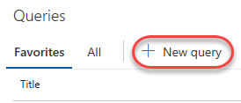

1. Set the first term to **Work Item Type = Task** and the second term to **Area Path = Parts Unlimited\PUL-Web**.

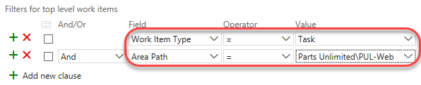

1. Click **Save q uery**.



1. Set the **Name** to **“Web tasks”** and the **Folder** to **Shared Queries**. Click **OK**.

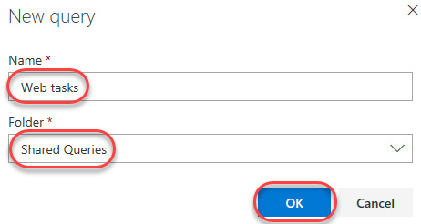

1. Select the **Charts** tab and click **New chart**.



1. Set the **Name** of the chart to **“Web tasks – By assignment”** and **Group by** to **Assigned To**. Click **OK** to save.

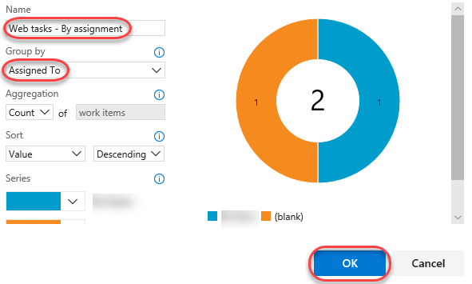

1. You can now add this chart to a dashboard.

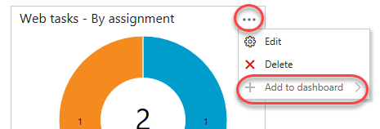

## Task 6: Customizing team process

In VSTS, you customize your work tracking experience through a process. A process defines the building blocks of the work item tracking system as well as other sub-systems you access through Team Services. Whenever you create a team project, you select the process which contains the building blocks you want for your project.

VSTS supports two process types. The first, the core system processes—Scrum, Agile, and CMMI system processes—are locked. You cannot customize these processes. The second type, inherited processes, you create from a core system process. These processes you can customize.

In addition, all processes are shared. That is, one or more team projects can reference a single process. Instead of customizing a single team project, you customize a process. Changes made to the process automatically update all team projects that reference that process.

Once you’ve created an inherited process, you can customize it, create team projects based on it, and migrate existing team projects to reference it. The Git team project can’t be customized until it’s migrated to an inherited process.

In this task we’ll create a new process that inherits Scrum. The one change we’ll make is to add a backlog item field designed to track to a proprietary PartsUnlimited ticket ID.

1. Click the **VSTS** log in the top left corner to navigate to the account root. From the menu dropdown, select **Settings**. These are account-level settings.

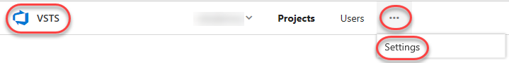

1. Select the **Process** tab under **Work**.

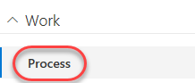

1. From the **Scrum** dropdown, select **Create inherited process**.

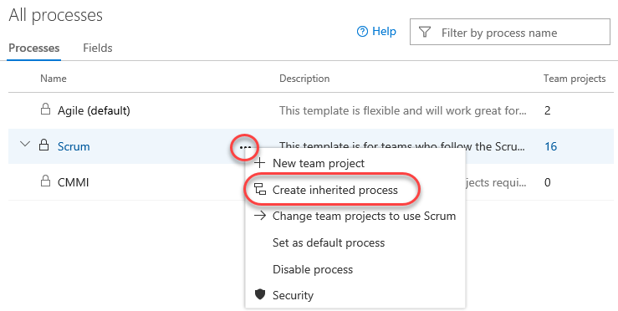

1. Set the name of the inherited process to **Customized Scrum** and click **Create process**.

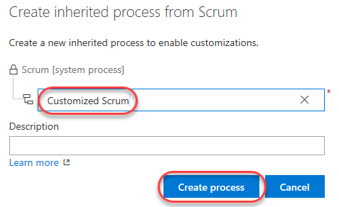

1. Open **Customized Scrum**. You may need to refresh the browser for this to become visible.

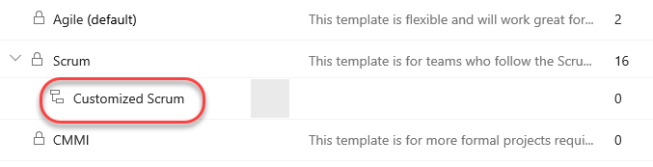

1. Select **Product Backlog Item**.

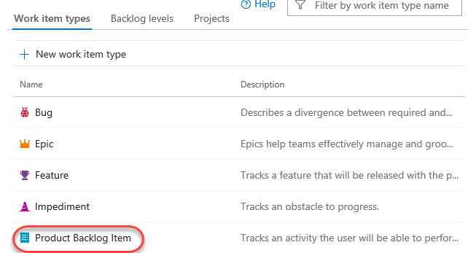

1. Click **New field**.

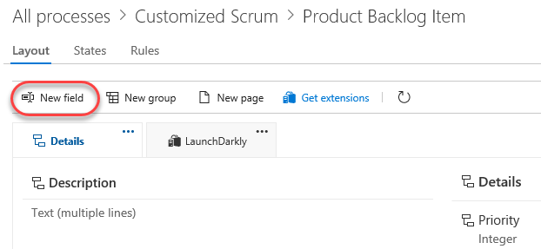

1. Set the **Name** of the new field to **“PUL Ticket ID”**.

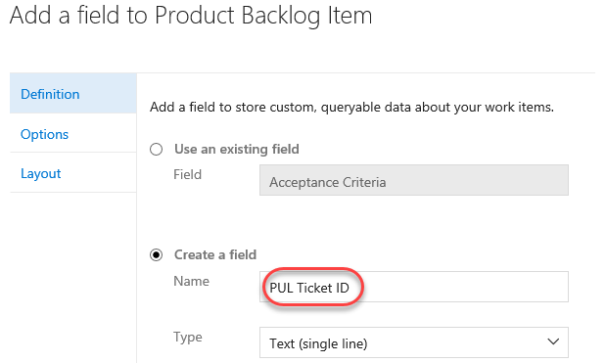

1. On the **Layout** tab, set the **Label** to **“Ticket ID”**. Also **Create a new group** for **“PartsUnlimited”**. Click **Add field**.

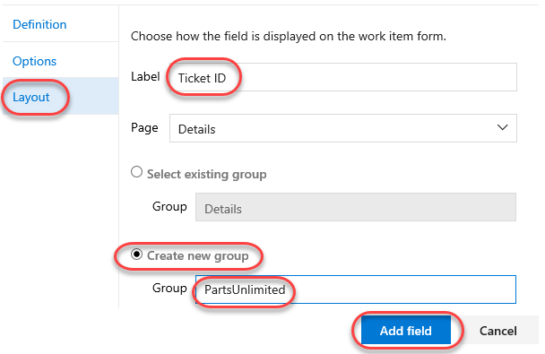

1. Return to the **All processes** root using the breadcrumb.

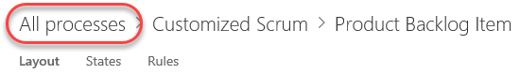

1. From the **Customized Scrum** dropdown, select **Change team projects to use Customized Scrum**.

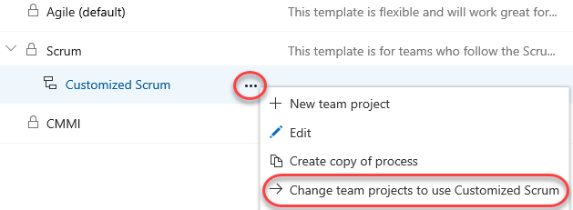

1. Select **Parts Unlimited** and click **Ok**.

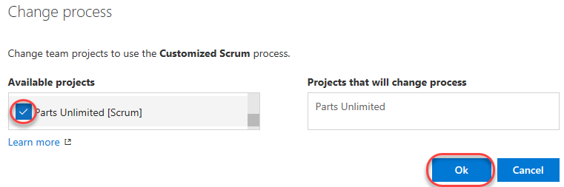

1. Return to the account dashboard using the logo link.



1. Open the **Parts Unlimited** portal.

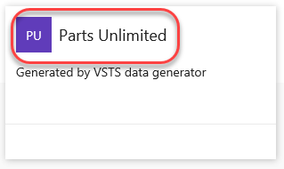

1. Select **Work | Work Items**.

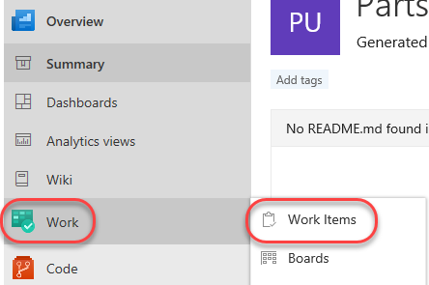

1. Open the first backlog item.

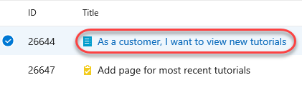

1. You will now see the **Ticket ID** field under the **PartsUnlimited** group defined during the process customization. You can treat this like any other text field.

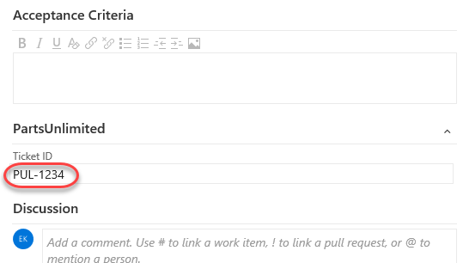

1. Once the work item is saved, VSTS will also save the new custom information so that it will be available for queries and the rest of VSTS.